Efficacy of bent angle needle goniectomy as a primary and redo surgery for management of pediatric glaucoma
Abstract
Background: To evaluate the effectiveness of bent angle needle goniectomy (BANG) in treating congenital glaucoma, whether as a primary or secondary treatment following previous failure surgeries. Methods: This study focused on paediatric glaucoma patients who underwent BANG at the Benha glaucoma unit between 2020 and 2023. Patients were divided into two groups: Group A included patients who underwent BANG as a primary procedure, while Group B comprised patients who had BANG as a secondary procedure. Group A was divided into neonatal (A1) and infantile (A2) categories. Group B was subdivided into the post-trabeculotomy group (B1) and the post-trabeculectomy group (B2). Success was determined by an intraocular pressure (IOP) of 20 mmHg or less, with or without medications. Results: Forty-eight eyes of thirty-nine children were examined. Both groups experienced a significant reduction in intraocular pressure (IOP) after BANG. At the end of one year of follow-up, groups A and B showed reductions in IOP of 52.4% and 50.1% respectively. Success rates for primary and redo surgeries were 75% and 62.5% respectively. The success rate was higher in group A2 (81.25%) compared to group A1 (62.5%). Conversely, post-trabeculotomy was more successful (64.28%) than post-trabeculectomy (60%). The failure rate was higher in eyes with higher baseline IOP, longer axial length, larger corneal diameter and positive consanguinity. There were no significant intraoperative or postoperative complications. Conclusion: BANG is an effective surgery for managing paediatric glaucoma. It can also be used as a secondary surgery following unsuccessful previous procedures.
Keywords: goniectomy; congenital glaucoma; intraocular pressure; primary surgery; redo surgery.
Introduction:
Pediatric glaucoma is a potentially blinding and challenging disorder, both in terms of diagnosis and treatment. Blindness resulting from glaucoma can happen even with suitable management therapy ^{[1,2]}. Pediatric glaucoma operation is more challenging, has a more diverse and complex pathophysiology, a greater potential for failure, and is more prone to complications compared to adult glaucoma ^{[3]}.
The primary pathology in primary congenital glaucoma involves the anterior chamber angle, making angle operation the predominant operation. Angle surgery aims to restore the normal anatomy and physiology of the angle by eliminating the obstruction and re-establish the standard aqueous outflow from AC to Schlemm’s canal ^{[4]}.
Otto initially described Goniotomy in 1938 ^{[5]}. It involves visualising angle structures using a goniolens & employing a needle or a blade to make 120 degrees circumferential incision in trabecular meshwork. This enables the overriding iris to retract posteriorly, granting aqueous humour access to Schlemm’s canal & trabecular meshwork. Its benefits include a short operating time, a conjunctiva-sparing nature, the potential for repeatability in another quadrant, and a relatively low incidence of complications when conducted by a specialist experienced in this procedure
Bent angle needle goniectomy acts as an economical substitute to numerous trabecular meshwork-based glaucoma operations. This procedure is a form of excisional goniotomy utilizing a standard hypodermic needle- which the surgeon modifies to function as a reverse cystotome- facilitating the complete excision of a segment of trabecular meshwork ^{[6,7]}.
Several studies have demonstrated the effectiveness of bent-angle needle goniectomy in reducing intraocular pressure in adults with glaucoma ^{[8,9]}. However, few studies demonstrate the efficacy of bent-angle needle goniectomy in managing primary congenital glaucoma ^{[10]}. Consequently, this research aimed to assess the safety and efficacy of BANG as a primary or redo surgery for managing Primary Congenital Glaucoma.
Patients and methods:
This prospective clinical cohort research has been performed at the Benha University Glaucoma Unit, which included paediatric glaucoma patients who underwent Bent Angle Needle Goniectomy (BANG) between November 2020 and December 2023. The research adhered to the tenets of the Declaration of Helsinki, and the Benha University Ethical Committee granted ethical clearance for the research {M.D.16.12.2022}. Informed consent has been obtained from the parents of all patients participating in the research. This research involved 48 eyes of 39 cases diagnosed with Primary Congenital Glaucoma. Both eyes of the same cases were operated on in nine subjects., This study comprised 18 males and 21 females. The preoperative clinical data encompassed case's age at operations, sex, consanguinity, details of medical therapy, and history of prior glaucoma operations documented.
The diagnosis of patients as PCG was performed through a preoperative examination under general anaesthesia using Sevoflurane prior to the operation. The preoperative assessment involved an extensive evaluation of anterior segment: a surgical caliper has been utilized to determine the horizontal corneal diameter (white to white); intraocular pressure has been assessed with a hand-held Perkins applanation tonometer (Haag–Streit, Harlow, UK) immediately following general anaesthesia induction , while the case was sedated; the intraocular pressure was established by averaging 3 measurements; a gonioscopic examination of anterior chamber angle has been carried out utilizing a Swan-Jacob gonioprism (Alcon Vold Goniolens, Alcon Laboratories, USA); the clarity of the cornea was objectively graded utilizing a 4-stage system proposed ^{[11]} with alteration ^{[12]} . A fundus examination was performed using binocular indirect ophthalmoscopy to determine the cup-to-disc ratio, while axial length has been determined with A-scan ultrasonography (PacScan 300A, Sonomed Inc, NY, USA).
A clinical diagnosis of glaucoma was established regarding with CGRN guidelines ^{[13]} when two of the following criteria were met: a) Intraocular pressure exceeding 21mm Hg upon repeated assessments; b) alterations in the optic disc (narrowing of the neuroretinal rim, a progressive increase in the cup-to-disc ratio), cup-disc asymmetry≥ 0.2 or equal when the optic discs are of similar size, or localized rim thinning; c) corneal alterations involving corneal oedema, Haab striae, or diameters of ≥ 11mm in babies, >12mm in kids under one year, or, >13mm at any age; d) progressive myopia or myopic shift accompanied by a rise in ocular dimensions disproportionate to normative growth patterns.
After diagnosing patients as having PCG, patients (n=48) have been classified into two groups: Group A, which involved the eyes of cases who underwent goniectomy as a primary procedure (n=24), and Group B, which included the eyes of patients who underwent goniectomy as a secondary procedure after failed previous glaucoma surgeries (n=24). Group A was further subdivided into a neonatal group (A1) (number=eight) and an infantile group (A2) (number=16). Group B was further subdivided according to the type of surgery conducted before goniectomy into a post-trabeculotomy group (B1) (n=14) and a post-trabeculectomy group (B2) (n=10).
Inclusion Criteria:
- Primary congenital glaucoma with relatively clear cornea for gonioscopic visualization (corneal clarity grade I & II)
- Past failed prior glaucoma operation, either trabeculotomy or trabeculectomy, in group B
Exclusion Criteria:
- Secondary causes of congenital glaucoma involved Axenfeld-Reiger syndrome, aniridia, or surgical removal of cataract in infancy (for example. glaucoma following cataract operation).
- Hazy cornea or cornea not clear enough to get a gonioscopic view
- History of failed more than one glaucoma surgery in the same patient in Group B (for Standarization of conditions of patients).
Surgical procedure
All surgical manoeuvres have been conducted under general anaesthesia and complete aseptic conditions. The operation has been conducted from temporal side, addressing the 120 degrees of the nasal angle. A corneal stab incision of 2.4 mm was made using an MVR blade. Miochol ^{TM-E} (acetylcholine chloride intraocular solution) has been administrated into the anterior chamber to constrict pupil. The anterior chamber has been deepened by injecting a viscoelastic substance such as Healon (iOvisc, i-Medical, Germany). The patient and operating microscope were tilted to obtain a gonioscopic view by angling the case's head 30 degrees away from the surgeon and tilting the operating microscope 45 degrees towards the surgeon. A Swan Jacob lens (Alcon Vold Goniolens, Alcon Laboratories, United States of America) has been placed on cornea following lubricating the surface with sodium hyaluronate, allowing angle to come into clear view. A 25-gauge needle was bent at the tip to form an angle of nearly 90 degrees and was then introduced through the temporal corneal incision into the anterior chamber. A nasal goniectomy has been performed by inserting the tip into the trabecular meshwork (TM) and excising it up to about 120 to 180 degrees. A successful goniotomy was indicated by the anteriorly inserted iris retracting, forming a cleft in the angle (figure 1). The surgical microscope and the case’s head were returned to their primary position. Finally, Healon was washed out from the eye, and the anterior chamber was completely reformed with balanced salt solution. The incision was closed with a single 10-0 nylon suture, leaving the eye at the end of surgery under relatively high pressure to prevent rebleeding from the excised raw area and worsening of hyphema. At the end of the surgery, intracameral moxifloxacin and subconjunctival dexamethasone were injected. Following surgery, all infants have been managed with topical Betamethasone sodium phosphate 0.1% percent & Moxifloxacin (5 milligram per milliliter) eye drops five times daily for four weeks. The steroid eye drops have been tapered per week and then discontinued. Corneal stitch was removed one week after the operation under general anaesthesia.
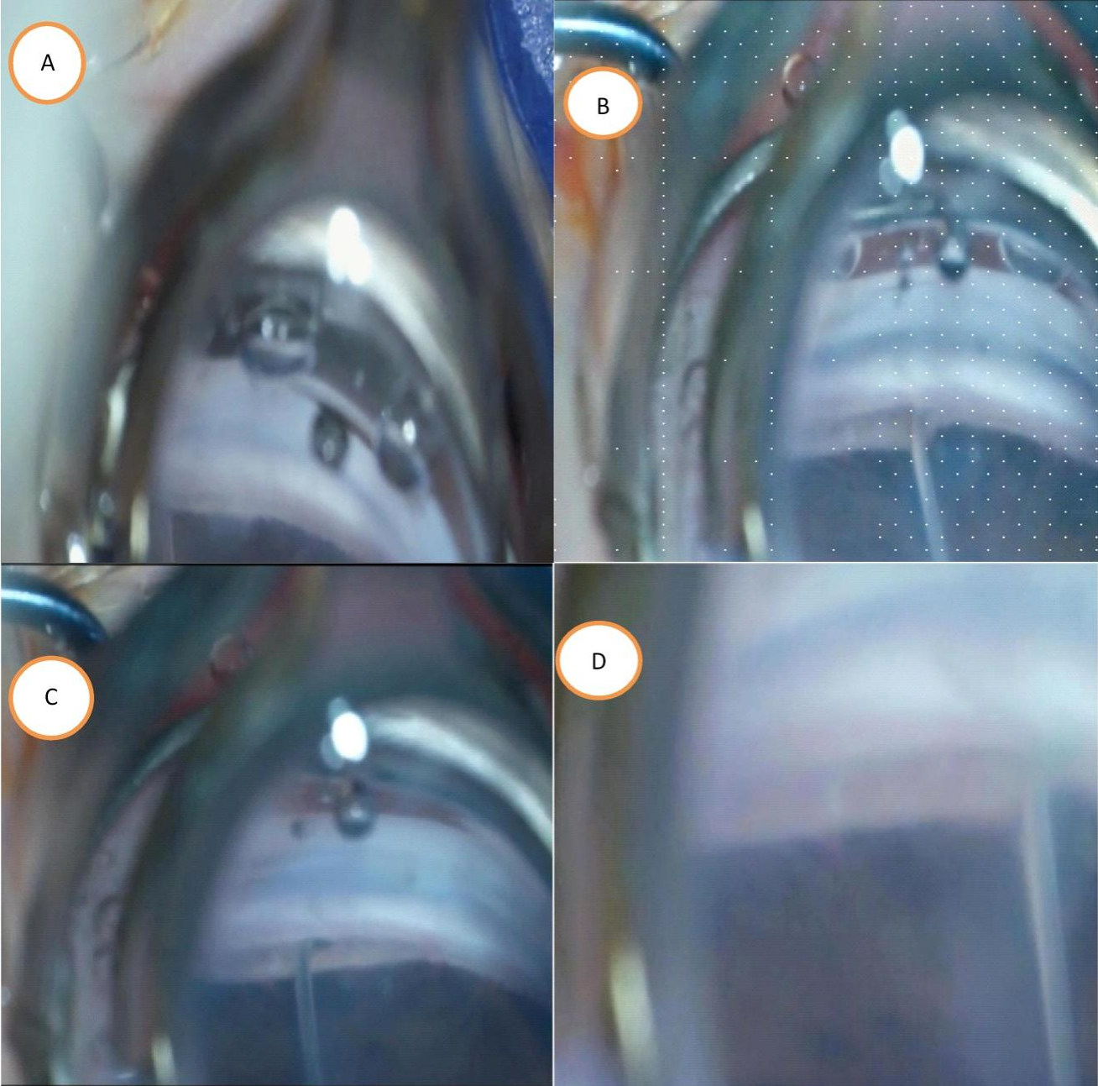
Figure (1): Intraoperative view of angle before and after BANG
- Intraoperative observation via Swan Jacob lens of unmanaged angle; (B) The same angle was observed intraoperatively following the BANG procedure (in treated angle ,iris had fallen backward at lower level than untreated (C) Further advancement of 25 g needle for treatment of wider area of angle (D) Magnified view of the cleft showed wider separation of upper and lower leaflets of cleft
Follow up
Postoperatively, all cases have been followed for one year and examined at one day, one week, one month, three months, six months, nine months, and twelve months. Follow-up was conducted under the sedative effect of oral chloral hydrate syrup (Chloral Hydrate Mixture one gram per ten milliliter (one hundred milligram per milliliter), manufacturer: Perrigo Australia). At each follow-up, the IOP, corneal diameter, corneal clarity, number of antiglaucoma medications, cup-to-disc ratio, and axial length- have been recorded,
Outcomes of surgery
The primary outcomes were assessed based on intraocular pressure control and the necessity for additional glaucoma operations. Complete success has been categorized by IOP ≤20 mmHg without medication, whereas qualified success was regarded as an IOP ≤20 mmHg with the use of up to two topical drugs. Failure has been defined as an IOP exceeding 20 mmHg on two topical medications, an IOP ≤20 mmHg on more than two topical drugs, the necessity for systemic medication for IOP management, or the need for re-surgery.
Statistical analysis
Data were expressed as Mean ± Standard Deviation. Statistical analysis has been carried out utilizing GraphPad Prism 5 software (GraphPad Software, Inc., La Jolla, CA, USA). The variance was regarded as significant at P≤0.05. The acquired data indicates that the subsequent tests were carried out: Unpaired Student's t-test for the demographic data analysis. A One-Way Analysis of Variance (ANOVA) with subsequent Tukey-Kramer post hoc test was utilized for comparing baseline characteristics and intraocular pressure decrease among the examined subgroups. A Two-Way Analysis of Variance (ANOVA) with subsequent Bonferroni post hoc test has been utilized to compare time course-dependent intraocular pressure alterations among the examined subgroups.
Results:
Data from 48 eyes (39 patients) were collected and analyzed preoperatively and postoperatively. The mean age of cases at the time of operation was 3.9 ± 1.6 months in group A and 19.05 ± 1.5 months within group B. Cases in group A were significantly younger compared to cases in group B (P-value <0.0001) [Table 1]. Regarding age across the four subgroups, the mean age of cases at the time of operation was 0.6 ± 0.2, 7.1 ± 3, 10.5 ± 1.1, and 27.6 ± 2 months in groups A1, A2, B1, and B2, respectively. A highly significant variance was discovered in age between the four groups (P-value <0.0001) [Table 2], with the youngest patients found in group A1 and the oldest in group B2.
Males comprised 58.5% of Group A cases and 36.36% of Group B cases, while females accounted for 63.64% within Group and B41.18% within Group A. There were 11 eyes with positive consanguinity (5 eyes in Group A and 6 eyes in Group B) [Table 1].
Regarding the preoperative assessment of cases in groups B and A, the corneal diameter in group A was significantly below in group B (P-value <0.001). This may be because of the presence of neonatal age group patients, who have different baseline and abnormal parameters compared to older patients. Insignificant variance was observed in preoperative IOP or CD ratio between groups A and B. A highly significant variance was observed in the number of antiglaucoma medications among both groups (P-value <0.0001) [Table 1]. Concerning the preoperative assessment in patients across the four groups, the corneal diameter in group A1 was significantly less than in all other groups (P-value <0.0001), and a highly significant variance was observed in corneal diameter between patients in groups B1 and B2 [Table 2]. Nevertheless, the preoperative IOP in group B2 was significantly greater than in group B1 (P-value <0.05). Insignificant variance was observed in the CD ratio among all four groups.
Regarding pre-operative antiglaucoma medication, there was no significant difference in all four subgroups [2].
Table (1): Demographic data of examined cases in groups A and B.
Demographic data and preoperative parameters  Groups | Group A  Number=24 | Group B  Number =24 | P value
Age at time of operation (months)  Mean± standard deviation (months) | 3.9 ± 1.6 | 19.05 ± 1.5 | P<0.0001***
Sex | Male (10/17)  Female (7/17) | Male (8/22)  Female(14/22) | ---
Consanguinity | Positive (5/24)  Negative (19/24) | Positive (6/24)  Negative (18/24) | ---
Corneal diameter  (Mean± standard deviation) (mm) | 12.45± 0.4 | 13.85± 0.2 | P<0.001**
(Cup to disc ratio )  Mean± standard deviation | 0.73± 0.15 | 0.815± 0.2 | P=0.1026
Intraocular pressure (Mean±SD) (mm Hg) | 27.9± 2.8 | 28.7± 3.2 | P=0.9851
Antiglaucoma Medications | 3 | 3 | P>0.05
Table (2): Baseline characteristics of studied cases in group A1, A2, B1 and B2
Demographic data and preoperative parameters  Groups | Group A1  Number =8 | Group A2  Number =16 | Group B1  Number =14 |  | Group B2  Number =10 | P value
Age at time of surgery (months)  Mean± standard deviation (months) | 0.6± 0.2 | 7.1± 3 | 10.5± 1.1 |  | 27.6± 2 | P<0.0001***  All sub groups are significant from each other
Corneal diameter  (Mean±SD) (mm) | 12.1± 0.4 | 13.8± 0.5 | 13.5± .3 |  | 14.2± 0.1 | P<0.0001***  All sub groups are significant from each other except  A2 vs B1(p>0.05)  A2 vs B1(p>0.05)
Cup to disc ratio  Mean±SD | 0.71± 0.1 | 0.75± 0.2 | 0.81± .1 |  | 0.82±0.2 | P>0.05  All sub groups are non-significant from each other
Intraocular pressure (Mean±SD) (mm Hg) | 27.25 ± 2.5 | 28.6 ± 3.1 | 26.25 ±3.8 | 30.3 ± 2.6 |  | B1 VS B2 (P<0.05)*
Antiglaucoma Medications | 3 | 3 | 3 | 3 |  | P>0.05
Data were expressed as mean ± standard deviation and statistically analysed utilising GraphPad Software via one-way ANOVA followed by Tukey-Kramer post hoc test. ***p≤0.0001 is statistically highly significant. P<0.05* is statistically significant.

Regarding the outcomes of BANG as a primary surgery over a 12-month follow-up, data in Table (3) explain the changes in intraocular pressure in groups A1 and A2 throughout the monitoring duration. In group A1, the mean preoperative IOP among the studied patients was 27.25 ± 2.5 mmHg. When assessing the postoperative IOP at various time points, group A1 exhibited the most significant drop in IOP over the first three months, with a mean postoperative IOP of 15 ± 1.2 millimeters of mercury at one month (P < 0.001**) and 14 ± 0.8 mmHg at three months. This was followed by a spike in IOP at 6 months following surgery, with a significant rise in intraocular Pressure compared to the three-month measurement, where the mean IOP was 20 ± 0.81 (P < 0.001). The IOP then plateaued at similar values at nine and twelve months postoperatively, with postoperative IOP measurements of 18 ± 0.9 and 18.5 ± 1.2 at nine and twelve months, respectively (P > 0.05).
Post-operative follow-up of Group A2 showed the maximum drop in IOP over the first three months, with a mean postoperative IOP of 11±1.2. This was followed by an IOP spike six months post-operatively, where the mean IOP was 15±1.1. It then declined and returned primarily to the same level as the initial drop in the first three months, with a post-operative IOP of 12.2±2.5 at the end of the one-year monitoring duration [Table 3, Figure 2].
When comparing groups A1 and A2, insignificant variance was discovered in preoperative IOP. However, over the twelve-month monitoring, the IOP in group A2 was significantly lower than that in group A1, showing a highly significant difference at the six- and twelve-month monitoring duration (p-value<0.001) [Table 3, figure 3].
Conversely, as a secondary surgery, the data in Table (4) explain the change in intraocular pressure in groups B1 and B2 over the 12-month monitoring period. Group B1 demonstrated a highly significant decrease in IOP from 26.25±3.8 mmHg preoperatively to 13±1.1, 14±1.5, 15±1.7, 16±2, and 14±1.5 mmHg at one month, three months, six months, nine months, and twelve months respectively (P-value<0.001**). Comparing each postoperative reading with the previous one, there were statistically significant changes at 1 month from preoperative readings (P<0.001**) with no significant change in IOP until the end of the 1-year follow-up. [Table (4), Figure 4].
Conversely, Group B2 showed a significant initial rise in IOP from 30.3 ± 2.6 mmHg to 15 ± 1.9 mmHg at 1 month post-operatively (P-value < 0.001**), followed by a notable increase at 3 months post-operatively where the mean IOP was 18 ± 1.7 millimeters of mercury (P-value < 0.001**). This then plateaued until the 1-year end monitoring duration, where the mean IOP was 18 ± 1.1 millimeters of mercury. [Table (4), Figure 4] .
In comparing groups B1 and B2, the preoperative intraocular pressure was significantly greater in group B2 compared to in group B1 (p-value<0.001). During the postoperative monitoring duration, the intraocular pressure within group B1 was significantly below that in group B2 at three months, six months, and twelve months following surgery (p-value <0.001) [Table (4), Figure 5].

Table (3): Postoperative and Preoperative Intraocular Pressure (IOP) in Group A(A1 and A2)over 12 months follow up in one month, three months, six months, and twelve months
Time Point | Group A1 |  | Group A2 |  | P Value (comparing AI and A2 in every time point )
Time Point | IOP | Test | IOP | Test | P Value (comparing AI and A2 in every time point )
Time Point | (mmHg)  Mean±SD | P  (each reading compared to previous reading) | (mmHg)  Mean±SD | P  (each reading compared to previous reading) | P Value (comparing AI and A2 in every time point )
Preoperative | 27.25 ± 2.5 | -- | 28.6 ± 3.1 |  | P>0.05
1 month postop | 15±1.2 ^{a,c,d,e,f} | P<0.001** | 12±0.83 ^{A,D,E} | P<0.001** | P<0.01*
3 month postop | 14±0.8 ^{a,d,e,f} | P>0.05 | 11±1.2 ^{A,D,E} | P>0.05 | P<0.01*
6 month postop | 20±0.8 ^{a,b,c} | P<0.001** | 15±1.1 ^{A,B,C,F} | P<0.001** | P<0.001**
9 month postop | 18±0.9 ^{a,b,c} | P>0.05 | 15±1.4 ^{A,B,C,F} | P>0.05 | P<0.01*
12 month postop | 18.5 ± 1.2 ^{a,b,c} | P>0.05 | 12.2 ± 2.5 ^{A,D,E} | P<0.001** | P<0.001**
Information are obtainable as mean ± standard deviation and statistically analyzed utilizing Graph Pad Software Program by two way ANOVA followed by Bonferroni post test
a :significant variance from preoperative IOP A1 Group
A: :significant variance from preoperative IOP A2 Group
b: significant variance from 1 month post operative IOP in A1 Group
B: significant difference from 1 month post operative IOP in A2 Group
c: significant difference from 3months post operative IOP in A1 Group
C: significant difference from 3 month post operative IOP in A2
d: significant difference from 6 months post operative IOP in A1 Group
D: significant difference from 6month post operative IOP in A2
e: significant difference from 9 months post operative IOP in A1 Group
E: significant difference from9 month post operative IOP in A2 Group
f: significant difference from 12 months post operative IOP in A1 Group
F: significant difference from 12 month post operative IOP in A2
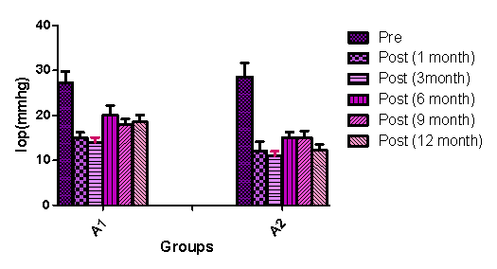
Figure (2): Preoperative and Postoperative Intraocular Pressure (IOP) in Group A(A1 and A2)over 12months follow up in 1month ,3months ,6months and12 months
Information are represented as mean ± standard deviation and statistically analyzed utilizing Graph Pad Software Program by 2 way ANOVA followed by Bonferroni post test
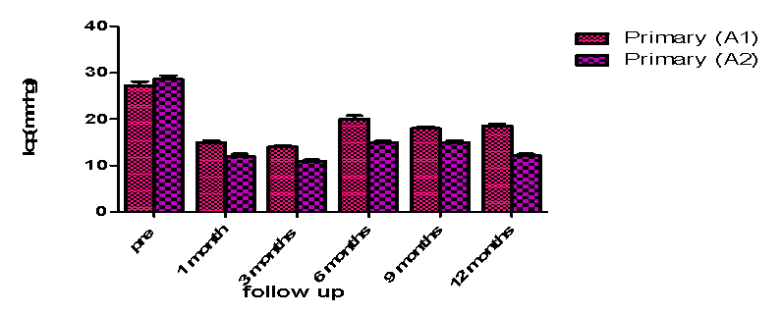
Fig. (3): Comparison between group A1 and A2 regarding Preoperative and Postoperative Intraocular Pressure over 12 months follow up
Information are represented as mean ± standard deviation and statistically examined utilizing Graph Pad Software Program by two way ANOVA followed by Bonferroni post test

Table (4): Preoperative and Postoperative Intraocular Pressure (IOP) in GroupB(B1 and B2)over 12months follow up in 1month ,3months ,6months and12 months
Time Point | Group B1 |  | Group B2 |  | P Value (comparing B1and B2 in every time point)
Time Point | IOP | Test | IOP | Test | P Value (comparing B1and B2 in every time point)
Time Point | (mmHg)  Mean±SD | P  (each reading compared to previous reading) | (mmHg)  Mean±SD | P  (each reading compared to previous reading) | P Value (comparing B1and B2 in every time point)
Preoperative | 26.25 ±3.8 | -- | 30.3 ± 2.6 |  | P<0.001**
1 month postop | 13±1.1^{a,e} | P<0.001** | 15±1.9^{A,C,D,E,F} | P<0.001** | P>0.05
3 month postop | 14±1.5 ª | P>0.05 | 18±1.7^{A,B} | P<0.001** | P<0.001**
6 month postop | 15±1.7 ª | P>0.05 | 18±1.9 ^{A,B} | P>0.05 | P<0.001**
9 month postop | 16±2 ^{a,b} | P>0.05 | 18±2 ^{A,B} | P>0.05 | P>0.05
12 month postop | 14±1.5 ª | P>0.05 | 18 ± 1.1^{A,B} | P>0.05 | P<0.001**
a: significant variance from preoperative IOP B1 Group
A: significant variance from preoperative IOP B2 Group
b: significant variance from 1 month post operative IOP in B1 Group
B: significant difference from 1 month post operative IOP in B2 Group
C: significant difference from 3 month post operative IOP in B2
D: significant difference from 6month post operative IOP in B2
e: significant variance from 9 months post operative IOP in B1 Group
E: significant difference from 9month post operative IOP in B2
F: significant difference from 12 month post operative IOP in B2
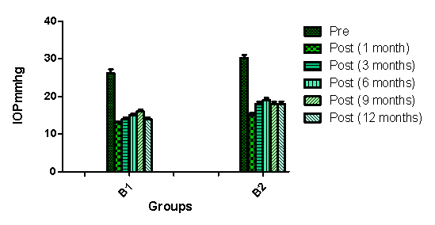
Figure (4)Preoperative and Postoperative Intraocular Pressure (IOP) in Group A(A1 and A2)over 12months follow up in 1month ,3months ,6months and12 months

Information are represented as mean ± standard deviation and statistically analyzed using Graph Pad Software Program by two way ANOVA followed by Bonferroni post test

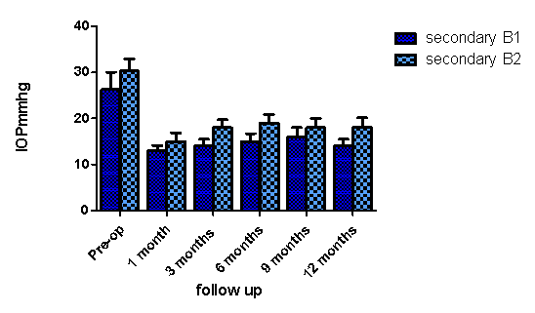

Fig. (5): Comparison between group B1 and B2 regarding Preoperative and Postoperative IOP over 12 months follow up
Data are represented as mean ± standard deviation and statistically examined utilizing Graph Pad Software Program by two way ANOVA followed by Bonferroni post test
Regarding the difference in intraocular pressure decrease percentage and the decrease in the number of anti-glaucoma medications at the end of the one-year follow-up in all four studied groups, the IOP reduction percentage was significantly greater in A2 compared to A1 (p-value<0.001) and significantly greater in B1 than B2(p-value <0.001).
Comparing all four groups, a significant variance was discovered in the percentage of IOP reduction among them. The greatest IOP reduction was observed in the A2 group (57.34 ± 0.55%), followed by the B1 group (46.66 ± 0.34%), with less IOP reduction in the B2 group (40.59 ± 0.19%), and the least reduction percentage in group A1 (32 ± 0.36%) (Table 5).
Comparing the number of drugs utilized to control intraocular pressure between the examined cases, the greatest reduction was observed in groups A2 and B1, while the least reduction occurred in Group A1 (Table 5)
Table (5): IOP reduction percentage and reduction in number of antiglaucoma medications at end of one year monitoring duration in group A1, A2, B1 and B2
Groups | IOP reduction percentage from preoperative IOP (at end of 1 year follow up  (mean ± SD)% | Reduction in number of antiglaucoma medications at end of one year monitoring
Group A1 | 32 ± 0.36 | -1
Group A2 | 57.34 ± 0.55 ^{a,c,d} | -2.5
Group B1 | 46.66 ± 0.34 ^{a,b,d} | -2.5
Group B2 | 40.59 ± 0.19 ^{a,b,c} | -2
Information is represented as mean ± standard deviation and statistically analyzed utilizing Graph Pad Software Program via one-way ANOVA at P-value<.05, followed by Tukey-Kramer post hoc test at P-value <.05.
a: significant variance from A1 group
b: significant variance from A2 group
c: significant variance from B1 group
d: significant variance from B2 group

Regarding different outcomes in goniectomy across the four groups, group A2 demonstrated more success than A1, with a success percentage of 81.25% in group A2 and 62.5% in group A1. Furthermore, most of the success in A1 was classified as qualified success (50%), whereas the majority of achievements in group A2 were of the complete type (62.5%)

On the other hand, complete success was more prevalent in group B1 (42.9%) than in group B2 (20%), whereas qualified success was greater in group B2 (40%) comparing with in group B1 (21.4%), which experienced a more significant failure rate group (40%)

Comparing groups A and B , Group B showed a greater failure rate(37.5%) than group A(25%) with more complete success in group A (45.8%)than group B (33.3%)

Comparing all four groups together, the greatest complete success was achieved in Group A2 (62.5%), followed by Group B1 (42.9%), then Group B2 (33.3%), with the lowest percentage of complete success achieved in Group A1 (12.5%). Failure was greatest in Group B2 (40%) and least in Group A2 (18.75%) [Table 6] [Figure 6]

Table (6): Success rates of secondary and primary BANG at the end of 1 year follow up
Outcomes of surgery  Groups | Primary goniectomy  N=24 |  | Total  N=24 | Secondary goniectomy  N=24 |  | Total  N=24
Outcomes of surgery  Groups | Group A1  n=8 | Group A2  n=16 | Group A | Group B1  n=14 | Group B2  N=10 | Group B
Complete success | 1 (12.5%) | 10 (62.5%) | 11(45.8%) | 6 (42.9%) | 2 (20%) | 8 (33.3%)
Qualified success | 4 (50%) | 3 (18.75%) | 7 (29.2%) | 3 (21.4%) | 4 (40%) | 7 (29.2%)
Failure | 3 (37.5%) | 3(18.75%) | 6 (25%) | 5 (35.7%) | 4 (40%) | 9 (37.5%)

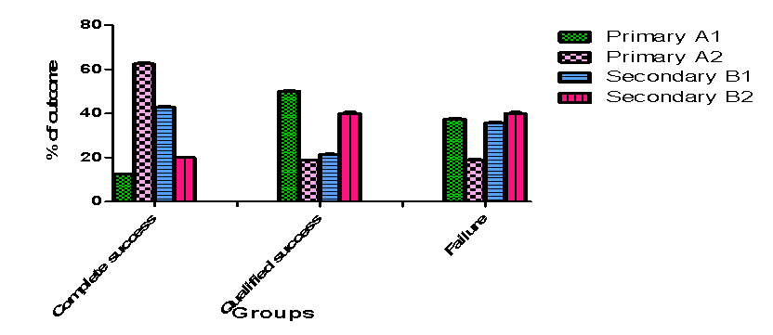
Figure (6): comparison between percentage of outcomes (qualified success, complete success, and failure) at end of one year monitoring period within group A1, A2, B1 and B2.
Discussion:
Primary congenital glaucoma is a serious form of glaucoma that results from genetically determined abnormalities in the trabecular meshwork and anterior chamber angle. These abnormalities elevate IOP, which may eventually lead to irreversible blindness ^{[14]}. PCG Affects over 300,000 kids globally and accounts for 5% of blindness in the pediatric population ^{[15]}.
Unique features of glaucoma in infants make its management more challenging due to the distensibility of the globe from birth until the age of two to three years that may reason stretching at all levels of the eye. These changes in normal anatomy render surgical handling of the thin and stretched tissue more challenging ^{[16]}.
Goniotomy bypasses the diseased trabecular meshwork in the eyes. The bypass of the trabecular meshwork enables the egress of aqueous humour from the anterior chamber into the Schlemm Canal and the distal outflow system .Various procedures are used to bypass TM either incisional or excisional techniques ^{[17,18,19]}.
Incisional goniotomy entails the incision of the trabecular meshwork, that may be done with a microvitreoretinal blade or the Trabectome® device. In contrast, excisional goniotomy involves the total removal of a segment of the trabecular meshwork, which can be performed using the Kahook Dual Blade® device or the TrabEx™/TrabEx+™.
Incisional methods disrupt however don’t eliminate trabecular meshwork tissue, leaving residual tissue on both sides of incision which may reapproximate and close ostomy. Excisional methods eliminate or ablate a segment of the trabecular meshwork ^{[20]}. Recent preclinical study of Ammar et al has proven that incisional goniotomy is more traumatic to the outer wall of Schlemm's canal and more liable for scar formation than excisional goniotomy^{[21]}.
Bent angle needle goniectomy (BANG) is a new, effective, and economical form of excisional goniotomy. It utilizes a needle to de-roof Schlemm’s canal (SC) instead of simply incising the trabecular meshwork in a single quadrant (typically nasal) to lower intraocular pressure.
Several studies have proved the efficiency of conventional goniotomy in managing primary congenital glaucoma ^{[22,23,24].} However, few studies demonstrate the efficacy of bent-angle needle goniectomy in managing primary congenital glaucoma glaucoma.
Our study is one of the leading investigations into the role of BANG in managing primary congenital glaucoma, including its safety, efficacy, and prognostic factors.
According to our study, BANG could be an excellent option as a primary surgery, especially in infantile primary congenital glaucoma. Our success rate was 81.25% in infantile-onset primary congenital glaucoma and 62.5% in neonatal-onset PCG.. These results agree with those of Gramer et al that reported that the main indicator of success is the timing of diagnosis, with elevated success rates for cases diagnosed among one month and two years of age ^{[25].}
In addition to the lower success rate of BANG in neonatal onset glaucoma compared with infantile-onset glaucoma, most successes in neonatal glaucoma were of a qualified type. The poor outcomes of angle surgery in neonatal onset glaucoma could be attributed to its greater severity, and this comes in harmony with the study of Walton and Katsavounidou which showed less efficacy of gonio-surgery in newborn primary congenital glaucoma with greater severity confirmed by genetic analysis ^{[26].}
This can also be explained by the fact that angle structures are not completely developed at birth and continue their development afterwards ^{[27]}. Therefore, angle surgeries in neonatal PCG are more susceptible to failure due to the underdevelopment of outflow structures, which cannot be addressed simply by removing the trabecular meshwork. Furthermore, failure may be attributed to mutations in the CYP1B1 gene which is more common In neonatal onset glaucoma ^{[28]}.
There are few studies concerning the efficacy of goniotomy following failed conjunctival surgeries ^{[29]}. These studies indicated that goniotomy appears to be a safe and effective technique for cases with a past of unsuccessful glaucoma operation. Our research was the first to demonstrate the efficacy of BANG as a secondary surgery for the treatment of PCG and established that the type of surgery influences both the success rate and the nature of the success.
Based on the outcomes of our research, BANG can be employed as a secondary surgery following a failed trabeculotomy. The success rate of BANG after trabeculotomy was 64.3%. BANG can also be utilized as an effective tool even after a failed trabeculectomy, with a success rate of 60%. The type of success varies according to the type of previous glaucoma surgery performed. In our study, the post-trabeculotomy group demonstrated a greater complete success rate (42.9%) compared to the qualified success rate (21.4%). Conversely, the majority of successes in the post-trabeculectomy group were of the qualified type (66.6%). Moreover, the percentage reduction in IOP was higher in post-trabeculotomy patients (46.66%) than in post-trabeculectomy patients (40.59%).
This can be explained by the structural changes in Schlemm's canal and the trabecular meshwork following filtering surgeries due to collapse of Schlemm's canal as the aqueous bypasses it and accumulation of abnormal extracellular material hindering aqueous outflow. The reduction in the size of Schlemm's canal after a successful filtration surgery may make glaucoma more challenging to control if the filter ultimately fails ^{[30]}.
Although the collapse of Schlemm's canal after filtering surgery can hinder success, angle surgeries can still be an effective management tool. We hypothesise that the success was partly due to some degree of dilation of Schlemm's canal following the failure of filtering surgery, related to the physiological passage of aqueous humour. Additionally, BANG is a type of excisional goniectomy that removes the abnormal extracellular material that accumulates because of under-perfusion, facilitating the free passage of aqueous through Schlemm's canal. Moreover, Dada et al demonstrated that BANG achieved adequate aqueous outflow channels in previously collapsed Schlemm's canal, as shown by aqueous angiography, indicating that BANG can still be effective even in cases of collapsed Schlemm's canal ^{[31]}.
The success of goniotomy following trabeculectomy was also reported in case series of uveitic glaucoma, which demonstrated the effectiveness of the Kahook dual blade goniotomy after unsuccessful previous trabeculectomy or valve surgery ^{[32]}.
On the other hand, post-trabeculotomy there is no collapse of Schlemm's canal and no accumulation of extracellular material, as it enhances the conventional pathway. Therefore, acting on another site with virgin trabecular meshwork may be the reason for success in these cases compared to post-trabeculectomy patients.
According to our study, BANG achieved the best results, the greatest success rate and greatest IOP reduction when it is perfomed as primary surgery specially in infantile onset PCG. As a secondary surgery, it achieved the best results when it is performed after trabeculotomy than after trabeculectomy .This can be explained by state of out flow system which is fully developed in infantile onset glaucoma on contrast to neonatal onset glaucoma and less affected virgin trabecular meshwork and schlemms canal in post trabeculotomy patients than post trabeculectomy patient
In agreement with the present findings, few studies are present about efficacy of BANG in management of PCG. Kaushik et al found that no difference between BANG and traditional goniotomy in control of IOP ^{[10]}. This study proved efficacy of BANG. But, from our point of view, equal efficacy of both BANG and traditional goniotomy in this study may be misleading for many reasons .This study included eight patients only. Operations were performed of both eyes of same patient where we expect that both eyes had asymmetrical conditions regarding corneal diameter and state of optic nerve which greatly affected the results on our study.
Another study from Nigeria comparing BANG to MVR incisional goniotomy and Kahook dual blade excisional goniotomy showed that goniotomy with a 23-gauge needle demonstrated the greatest postoperative IOP lowering effect, followed by the microvitreoretinal blade and the Kahook blade ^{[33]}. In our study, we used a 25-gauge needle, which is less traumatic to the target tissue than a 23-gauge needle, expecting greater efficacy. Additionally, race may affect the results, so we need to compare the Egyptian population similarly.
Conclusion
BANG could be a safe, effective, and economical method for the management of PCG. The greatest efficacy of BANG is achieved when it is used as a primary surgery, especially for infantile onset glaucoma. As a secondary surgery, BANG is more effective following trabeculotomy than after trabeculectomy.
Limitations in this research involve the small number of cases and a short monitoring period. Additionally, the classification of the secondary group needed to consider the age at which the disease presented, as this may be another contributing factor to the failure of the procedure.
References
- Kargi SH, Koc F, Biglan AW, Davis JS. Visual acuity in children with glaucoma. Ophthalmology. 2006 Feb 1;113(2):229-38.
- Allingham RR, Damji KF, Freedman SF, Moroi SE, Rhee DJ, Shields MB. Shields textbook of glaucoma. Lippincott Williams & Wilkins; 2012 Mar 28.
- Aktas Z, Gulpinar Ikiz GD. Current surgical techniques for the management of pediatric glaucoma: A literature review. Frontiers in Ophthalmology. 2023 Mar 22;3:1101281.
- Gagrani M, Garg I, Ghate D. Surgical interventions for primary congenital glaucoma. Cochrane Database of Systematic Reviews. 2020(8).
- Barkan O. Technic of goniotomy. Archives of Ophthalmology. 1938 Feb 1;19(2):217-23.
- Shute T, Green W, Liu J, Sheybani A. An alternate technique for goniotomy: description of procedure and preliminary results. Journal of Ophthalmic & Vision Research. 2022 Apr 29;17(2):170.
- Dada T, Bukke AN, Huang AS, Sharma N, Verma S. Recruitment of temporal aqueous outflow channels after bent needle ab-interno goniectomy demonstrated by aqueous angiography. Journal of glaucoma. 2023 Feb 1;32(2):e15-8.
- Eslami Y, Mohammadi M, Safizadeh M, Tabatabaei SM. Six-month outcomes of combined conventional needle goniotomy and phacoemulsification in eyes with early to moderate primary open-angle and pseudoexfoliation glaucoma and ocular hypertension. Indian Journal of Ophthalmology. 2022 Jun 1;70(6):2030-5.
- Bukke AN, Midha N, Mahalingam K, Beri N, Angmo D, Sharma N, et al. Outcomes of bent ab interno needle goniectomy with phacoemulsification in moderate to severe primary open angle glaucoma. Indian Journal of Ophthalmology. 2024 Sep 1;72(9):1280-4.
- Kaushik S, Gupta K, Hunashyal S, Sardana M, Thattaruthody F, Pandav SS. Comparison of bent ab-interno needle goniectomy and goniotomy in primary congenital glaucoma: a randomized controlled trial. Ophthalmology Glaucoma. 2025 Jan 1;8(1):46-52.
- Gupta N, Kalaivani M, Tandon R. Comparison of prognostic value of Roper Hall and Dua classification systems in acute ocular burns. British journal of ophthalmology. 2011 Feb 1;95(2):194-8.
- Choi H, Phillips C, Oh JY, Stock EM, Kim DK, Won JK, et al. Comprehensive modeling of corneal alkali injury in the rat eye. Current eye research. 2017 Oct 3;42(10):1348-57.
- Thau A, Lloyd M, Freedman S, Beck A, Grajewski A, Levin AV. New classification system for pediatric glaucoma: implications for clinical care and a research registry. Current opinion in ophthalmology. 2018 Sep 1;29(5):385-94.
- Dureau P. Congenital glaucoma and trabeculodysgenesis. Clinical and genetic aspects. Journal Francais d'Ophtalmologie. 2006 Feb 1;29(2):198-215.
- Gilbert C, Foster A. Childhood blindness in the context of VISION 2020: the right to sight. Bulletin of the World Health Organization. 2001;79(3):227-32.
- Robin AL, Quigley HA, Pollack IP, Maumenee AE, Maumenee IH. An analysis of visual acuity, visual fields, and disk cupping in childhood glaucoma. American journal of ophthalmology. 1979 Nov;88(5):847-58.
- Chen DZ, Sng CC. Safety and efficacy of microinvasive glaucoma surgery. Journal of Ophthalmology. 2017;2017(1):3182935.
- Lavia C, Dallorto L, Maule M, Ceccarelli M, Fea AM. Minimally-invasive glaucoma surgeries (MIGS) for open angle glaucoma: a systematic review and meta-analysis. PloS one. 2017 Aug 29;12(8):e0183142.
- Richter GM, Coleman AL. Minimally invasive glaucoma surgery: current status and future prospects. Clinical ophthalmology. 2016 Jan 28:189-206.
- Seibold LK, SooHoo JR, Ammar DA, Kahook MY. Preclinical investigation of ab interno trabeculectomy using a novel dual-blade device. American Journal of Ophthalmology. 2013 Mar 1;155(3):524-9.
- Ammar DA, Seibold LK, Kahook MY. Preclinical investigation of goniotomy using four different techniques. Clinical Ophthalmology. 2020 Oct 28:3519-25.
- Hassanein DH, Awadein A, Elhilali H. Factors associated with early and late failure after goniotomy for primary pediatric glaucoma. European Journal of Ophthalmology. 2020 Jan;30(1):162-7.
- El Sayed Y, Esmael A, Mettias N, El Sanabary Z, Gawdat G. Factors influencing the outcome of goniotomy and trabeculotomy in primary congenital glaucoma. British Journal of Ophthalmology. 2021 Sep 1;105(9):1250-5.
- Kaushik S, Gupta G, Thattaruthody F, Dhingra D, Kumari K, Arora A, et al. Goniotomy for initial and re-surgery for childhood glaucoma in Northern India. Indian Journal of Ophthalmology. 2021 Aug 1;69(8):2088-94.
- Gramer E, Tausch M, Kraemer C. Time of diagnosis, reoperations and longterm results of goniotomy in the treatment of primary congenital glaucoma: a clinical study. International ophthalmology. 1996 Jan;20:117-23.
- Walton DS, Katsavounidou G. Newborn primary congenital glaucoma: 2005 update. Journal of Pediatric Ophthalmology & Strabismus. 2005 Nov 1;42(6):333-41.
- Ramírez JM, Ramírez AI, Salazar JJ, Rojas B, De Hoz R, Triviño A. Schlemm’s canal and the collector channels at different developmental stages in the human eye. Cells Tissues Organs. 2005 Jan 1;178(3):180-5.
- Kaushik S, Luthra-Guptasarma M, Prasher D, Dhingra D, Singh N, Kumar A, et al. CYP1B1 and MYOC variants in neonatal-onset versus infantile-onset primary congenital glaucoma. British Journal of Ophthalmology. 2023 Feb 1;107(2):227-33.
- Lin F, Nie X, Shi J, Song Y, Lv A, Li X, et al. Safety and Efficacy of Goniotomy following Failed Surgery for Glaucoma. Journal of Glaucoma. 2023 Nov 1;32(11):942-7.
- Johnson DH, Matsumoto Y. Schlemm's canal becomes smaller after successful filtration surgery. Archives of ophthalmology. 2000 Sep 1;118(9):1251-6.
- Dada T, Bukke AN, Huang AS, Sharma N, Verma S. Recruitment of temporal aqueous outflow channels after bent needle ab-interno goniectomy demonstrated by aqueous angiography. Journal of glaucoma. 2023 Feb 1;32(2):e15-8.
- Krause MA, Lowder CY, Eisengart J. Kahook Dual Blade goniotomy after failed trabeculectomy or glaucoma drainage implant in patients with uveitic glaucoma. Investigative Ophthalmology & Visual Science. 2020 Jun 10;61(7):957-.
- Atima MO, Idakwo U, Orugun AJ, Komolafe O, Munaje MI, Shimizu E, et al. Prospective comparison of minimally invasive glaucoma surgery techniques for goniotomy in primary congenital glaucoma: Optimizing intraocular pressure control. Journal of Pediatric Surgery Open. 2024 Oct 1;8:100162.

